Mobile Application Development (IC 2305)
Department of Information and Communication Technology
University of Colombo

Student Name | W.M.K.C. Weerasekara
Student No. | 2023t01909
Application | TaskFlow
Design Tool | Figma
M3 Reference | https://m3.material.io/
Version | Release 1.0.0

Property | Value | Notes
Frame size | 412 × 917 dp | Standard M3 compact Android baseline device
Reference device | Android phone | Equivalent to Pixel 6 viewport
Design scale | 1x (100%) | All values in dp (density-independent pixels)
Color mode | Light mode | Primary brand color: Red #C62828
M3 baseline font | Roboto | Applied via M3 type scale tokens

- Introduction

Task Flow - Simply productive. This name was chosen because it is highly relevant to the application's purpose. It is memorable and clearly communicates that the app helps users maintain a steady workflow of their daily tasks.
Logo Design


The logo features a distinct checkmark forming a continuous, dynamic circle. It adheres to the principles of simplicity and clarity , utilizing a clean, scalable vector format that looks great on the application's splash screen and branding elements.

Design System And Theme
The application uses a bold, energetic color palette primarily utilizing pure Red and White. The high contrast ensures readability, while the wavy background patterns on the authentication screens provide a creative visual appeal without compromising usability.

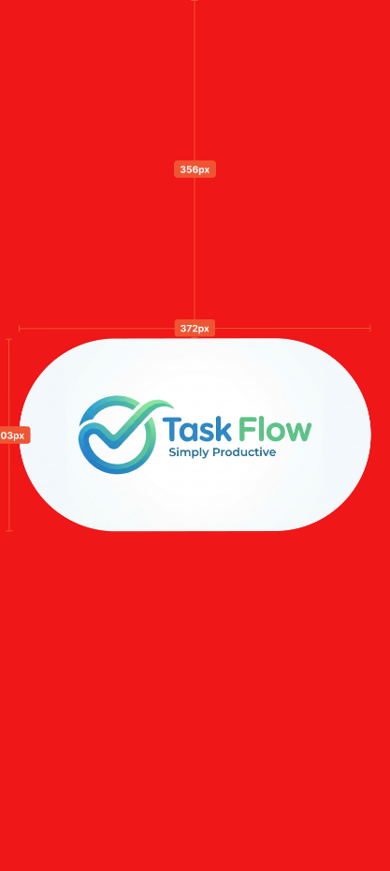
2.1 Splash Screen
Provides visual feedback that the app is loading and reinforces the brand identity.

Element | Category | Attribute | Value
Background | Container | Fill | Solid red
Logo container | Card | Shape | Pill/rounded rectangle
Brand logo | Image | Alignment | Center

2.2 Sign-in & Signup Screens
The interfaces where users input credentials (username, password, email) to access the application.

Element | Category | Attribute | Value
Screen title | Text (H4) | Typeface weight | Bold
Input fields | Text field | Height  Corner radius | 56 dp  4 dp
Input icons | Icon | Dimensions  Padding | 24x24 dp  16 dp Left
Login/Signup | Filled button | size | 64x346 dp
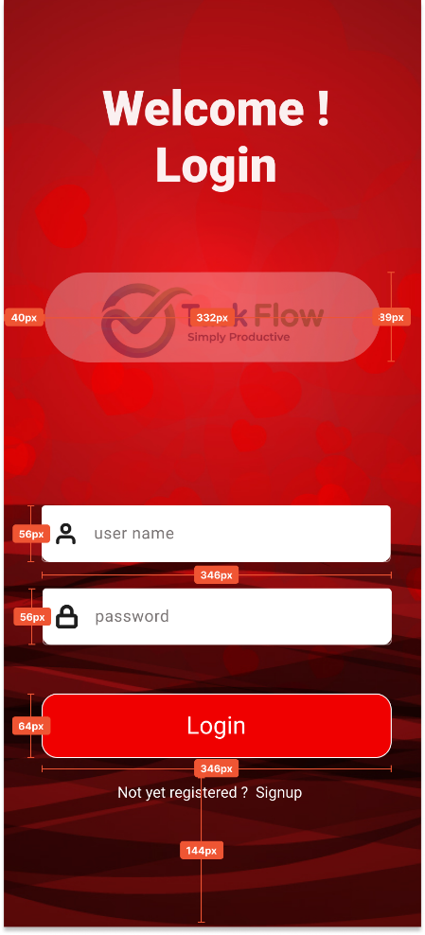

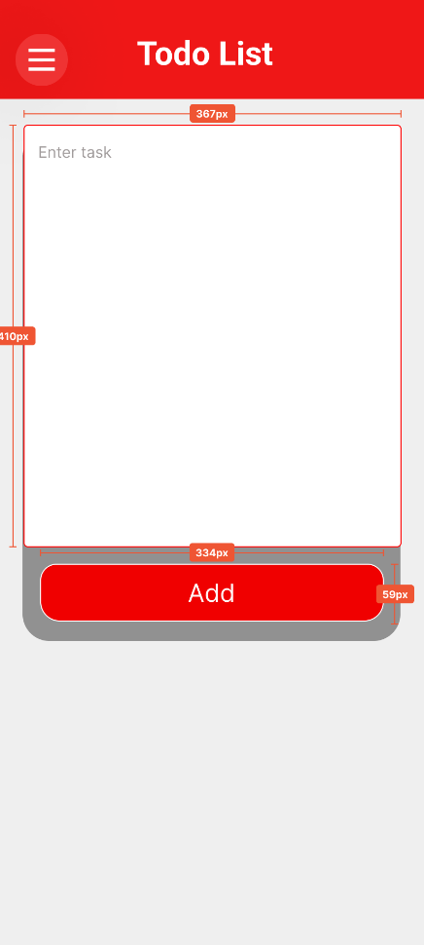
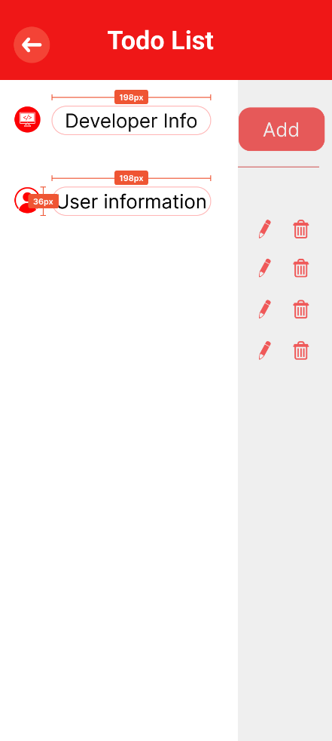
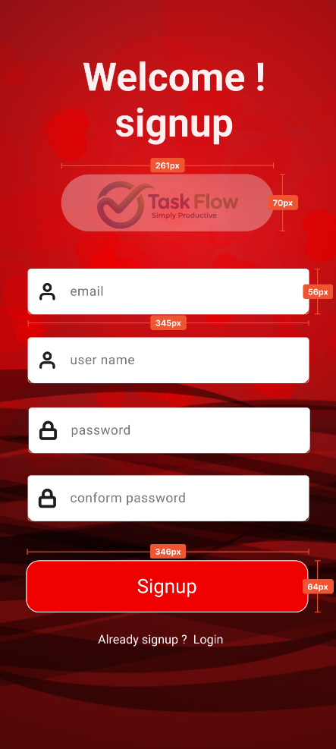
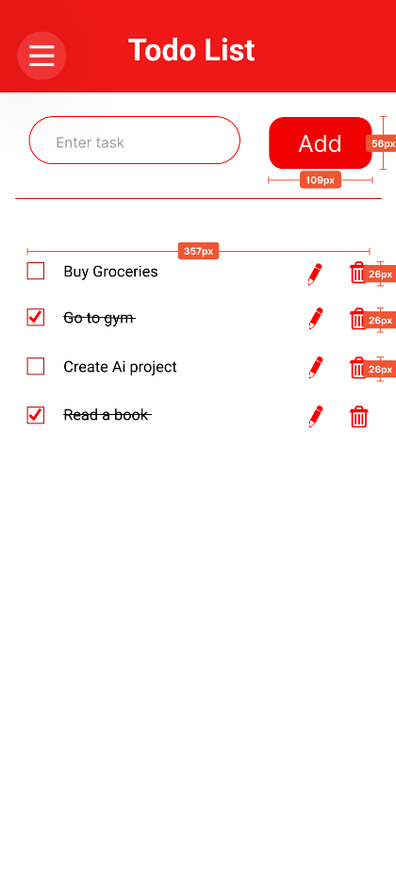
2.3 To-do Screen
The core interface where the user can add and manage their tasks.
Element | Category | Attribute | Value
Top app bar | App bar | Height | 64 dp
Menu icon | Icon button | Dimensions | 24x24 dp
Task input | Outlined field | Height  Border | 56 dp  Red Stroke
Add button | Filled button | Height | 48 dp
List item | List item | Padding | 16 dp Horizontal
Task actions | Icon button | Dimensions | 24x24 dp (edit/delete)
2.4 User Info Screen
Displays the registered user's information and provides account management options.
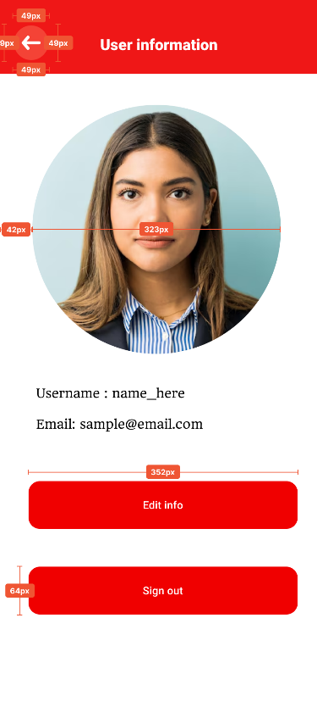
Element | Category | Attribute | Value
Profile image | Avatar | Shape  Dimensions | Circle  120x120 dp
User details | Text (body 1) | Alignment | Center
Action buttons | Filled button | Height  Margin bottom | 48 dp  16 dp
Edit modal | Dialog | Corner radius | 24 dp
Modal actions | Text button | Touch target | 48x48 dp (minimum)

2.5 Developer Info Screen
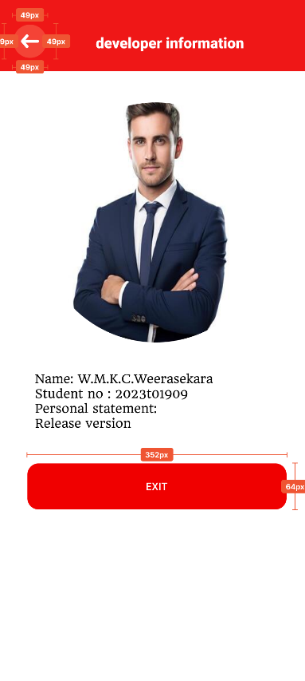
Displays the application developer's credentials and the release version.
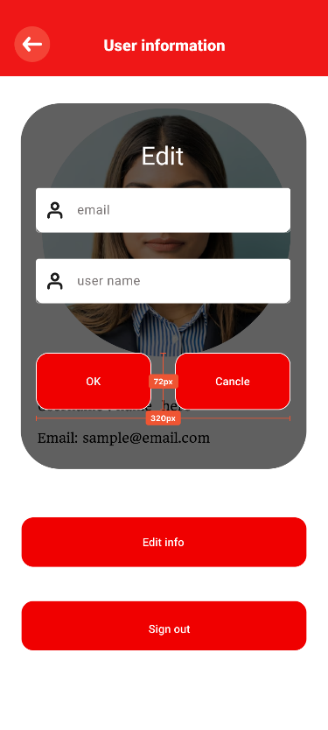
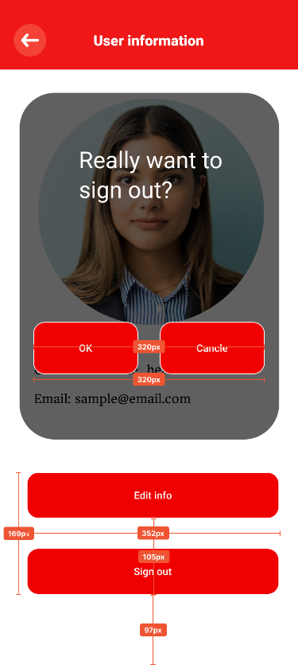
Element | Category | Attribute | Value
Dev photo | Avatar | Border | none
Info labels | Text (body 2) | Spacing | 8 dp vertical
Statement | Text (body 2) | Alignment | Left aligned

Typography:
- Font family: static/title medium
- Headlines: bold, 18–20px
- Body text: regular, 16px (readable without zoom)
- Secondary text: regular, 14px, gray
- Button text: semibold, 16px
Spacing:
- Consistent 16px padding
- 24px section spacing
- 12px between card elements
Why This works: Creates a micro-dopamine hit. The satisfying visual feedback encourages continued use. Small wins matter — checking off a task shouldn’t feel mundane, it should feel like progress.

